Letterkenny TidyTowns

Letterkenny TidyTowns - an informed advocate on behalf of the community for climate action at a local level.

Insights into:
Travel & Transport
Energy
Climate Action

Climate Action Survey Summary
May 2022

Introduction
Communities will be central to the Government’s response to climate disruption and the best environmental and social ideas inspiring change beginning in the heart of communities. We can only move towards a more sustainable future when awareness turns into action. Letterkenny TidyTowns has been actioning awareness raising initiatives in this area for some time.
Letterkenny TidyTowns developed an online survey during January and February 2022 which was open to the public during March and April.
The results of the survey will be shared with wider stakeholders and will inform the TidyTowns programme of projects and community work conducted in the future.
Individually, citizens can play their part through their homes, workplaces, their travel and consumer choices. Climate action on a local and community level is happening nationwide.

Survey Response Rate
A total of 437 respondents responded to our online Climate Action Survey. This report outlines the results.

Section 1: You and your relationship with Letterkenny
We asked these questions to get an initial understanding about the respondents answering the questionnaire and their relationship to Letterkenny.

Question 1: What age are you?
Just over 50% of respondents were under the age of 18. Over one quarter of respondents were aged between 45 to 64. The lowest response rate was in the 25 to 34 age bracket.

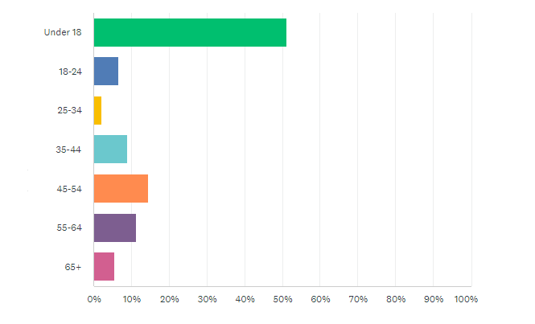 | Answer Choices Responses  Under 18 51.26%  18-24 6.64%  25-34 2.06%  35-44 8.92%  45-54 14.42%  55-64 11.21%  65+ 5.49%

Question 2: What is your gender?
There were many more female respondents to the climate action survey than male.
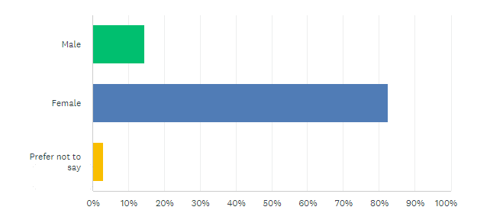 | Answer Choices Responses  Male 14.42%  Female 82.61%  Prefer not to say 2.97%

Question 3: What is your relationship to Letterkenny?
The majority of respondents live in Lettekrnny with the next largest proportion of respondents visiting Letterkenny for the purposes of shopping.
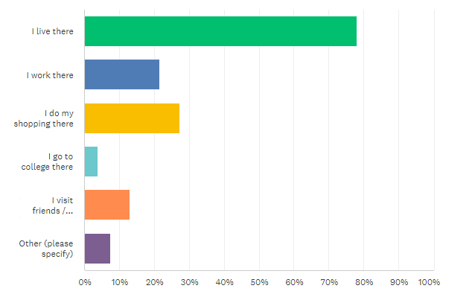 | Answer Choices Responses  I live there 77.98%  I work there 21.56%  I do my shopping there 27.29%  I go to college there 3.90%  I visit friends / family there 13.07%  Other (please specify 7.57%

Question 4: Thinking about your relationship to Letterkenny, what do you like about being associated with or connected to Letterkenny?
Some common answers from respondents related to:
- The wide-ranging shops and amenities available in Letterkenny.
- The friendly people and great sense of community spirit.
- Respondents feeling that Letterkenny was a safe town to live in.
- Letterkenny being clean and tidy
- Letterkenny’s social scene.

Question 5: Have you heard of Letterkenny TidyTowns? Do you understand the work the Tidy Town volunteer's do?
This answer tells us that we could do more about disseminating the work conducted by TidyTowns volunteers in Lettekenny.
While, over 42% of respondents stated that they fully understood the work conducted by the TidyTowns volunteers, nearly 30% had heard of Letterkenny TidyTowns but didn’t have an undestanding of what the TidyTowns volunteers did.
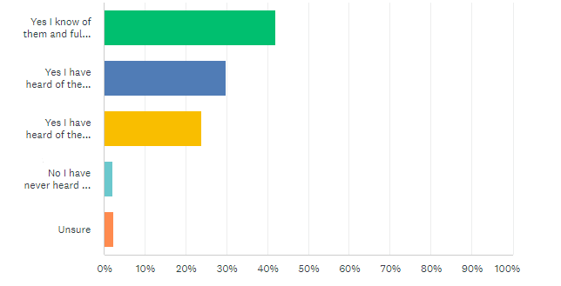
Answer Choices | Responses
Yes, I know of them & fully understand the work they do. | 42.11%
Yes, I have heard of them, but I don't really know what they do. | 29.75%
Yes, I have heard of them & know all about their litter collections and tidy ups. | 23.80%
No, I have never heard of them. | 2.06%
Unsure | 2.29%

Question 6: Thinking about climate action and the environment, what challenges does Letterkenny have or what would you like to see more of?
Specifically in relation to climate action and the environment the key themes respondents mentioned included:
- Issues with littering in some areas.
- Better cycling provision such as more cycle lanes
- The traffic congestion in Letterkenny
- The provision of additional green spaces
Not specifically in relation to climate change and the environment but in-keeping with the SDGs, the provision of public toilets was mentioned by respondents.

Section 2: Travel and Transport
We asked a series of questions to better understand how people travel in and around Letterkenny.

Question 7: What type of transport do you use most often?
As expected, cars are overwhelmingly the most common form of transport used in Letterkenny. Surprisingly, only 0.5% of respondents use a bike often in Letterkenny.
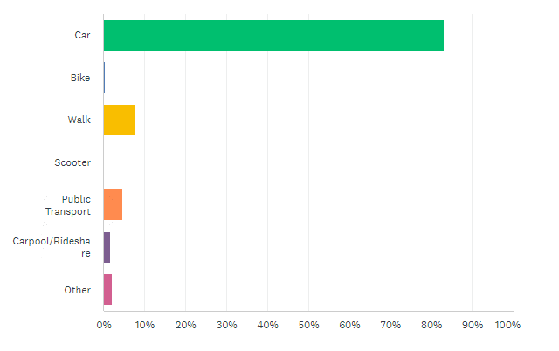 | Answer Choices Responses  Car 83.17%  Bike 0.50%  Walk 7.67%  Scooter 0.00%  Public Transport 4.70%  Carpool / Rideshare 1.73%  Other 2.23%

Question 8: If you do not take public transport, why not?
The most common answers given by respondents as to why they do not use public transport were in relation to there being no bus stops in the area, infrequent service and choice or range of destinations.
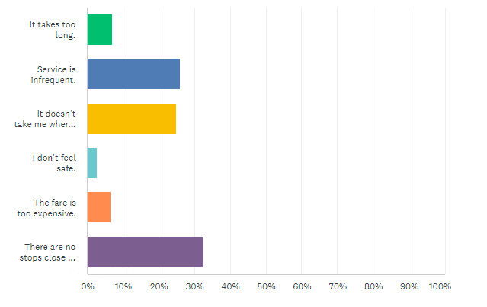
Answer Choices | Responses
There are no stops close to me. | 32.58%
Service is infrequent. | 26.06%
It doesn't take me where I need to go. | 24.93%
It takes too long. | 7.08%
The fare is too expensive. | 6.52%
I don't feel safe. | 2.83%

Question 9: Are you in walking/cycling/scooting distance of school/college/work?
The distance range to school / work / college is very interesting with nearly 25% of respondents living within 2km.
Answer Choices | Responses
Less than 1km to school/work/college. | 9.87%
Within 2km to school/work/college. | 14.29%
Within 3km to school/work/college. | 10.13%
Within 4km to school/work/college. | 7.27%
Within 5km to school/work/college. | 8.31%
Between 5-10km away from school/work/college. | 20.52%
Between 10-20km away from school/work/college. | 15.58%
Greater than 20km away from school/work/college. | 14.03%

Question 10: Do you or your child walk/cycle/scoot to school/college/work?
Despite many respondents living withing distance that would be considered suitable distance for walking and cycling to work / school / college, only 15.31% of respondents stated that they did walk / cycle / scoot to their destination.
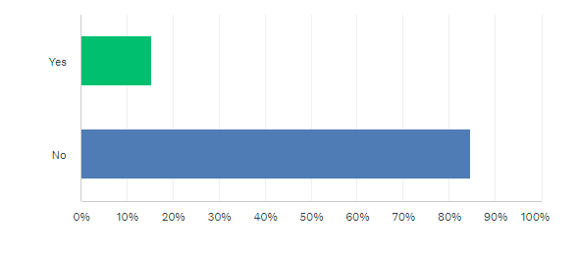Reasons why respondents didn’t walk or cycle related to the distance being too far and the roads being too busy and dangerous
Answer Choices | Responses
Distance is too far. | 51.64%
Roads are too busy / dangerous. | 13.73%
Time constraints | 11.34%
Other (please specify) | 9.85%
Weather | 7.16%
No footpath provision | 4.78%
Health reasons | 1.49%
Lighting is poor | 0.00%

Question 12: If you do regularly walk/cycle/scoot to school /college /work, why do you do it?
The reasons why those respondents who choose to who walk to school / college / work are set out in the table below.
Answer Choices | Responses
For fitness/exercise/health reasons. | 35.34%
I have no other transport means. | 24.14%
To get some fresh air | 20.69%
To do my bit for the environment. | 10.34%
It's quicker than driving or going via bus. | 9.48%

Question 13: If you do own a car, what kind of car?
Most respondents (71.88%) own a petrol- or diesel-powered car and 7.81% of respondents own either electric or a hybrid car.
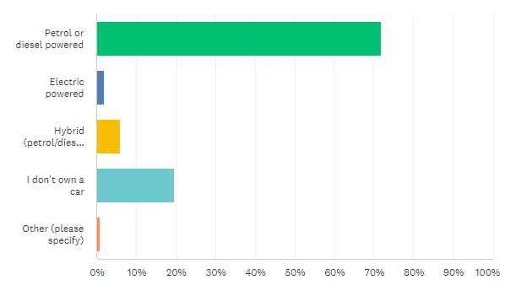

Question 14: If you don't drive an electric vehicle, why not?
The most common answer from respondents in relation to why they don’t drive an electric car is that they are too expensive. The lack of charging infrastructure in Letterkenny is also a deterrent to buying an electric vehicle.
Answer Choices | Responses
It is too expensive. | 44.65%
There is not enough charging infrastructure in Letterkenny. | 24.16%
I don't know enough about purchasing an electric vehicle. | 11.62%
I have no place to charge my car. | 7.95%
I don't think they are reliable | 5.81%
Nothing, I own an electric vehicle or a hybrid vehicle. | 5.81%

Question 15: Which of these alternative modes of transport (other than a car) would you consider using in Letterkenny?
The most frequent answer in relation to alternative modes of transport in Letterkenny related to improved public transport in terms of frequency and local destinations.
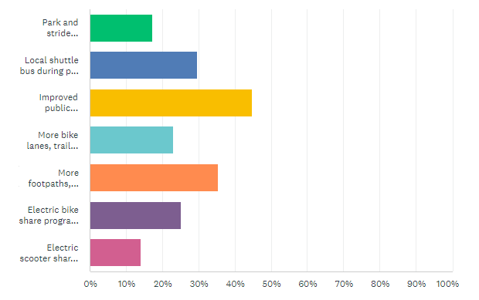
Answer Choices | Responses
Improved public transport in terms of frequency and local destinations | 44.87%
More footpaths, cross walks and signage giving walking distance and timings. | 35.38%
Local shuttle bus during peak commute times. | 29.74%
Electric bike share programme in Letterkenny. | 25.13%
More bike lanes, trails and covered bike parking infrastructure. | 23.08%
Park and stride facilities. | 17.18%
Electric scooter share programme in Letterkenny. | 14.10%

Section 4: Energy

Question 16: Does your home have a Building Energy Rating (BER)?
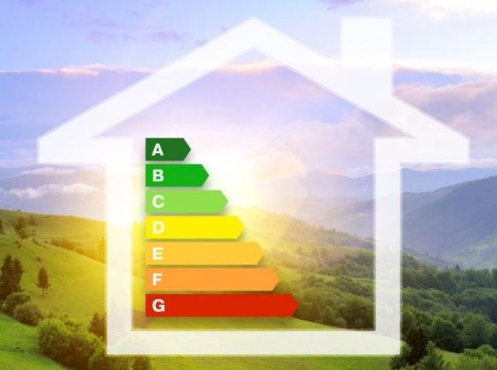
A Building Energy Rating (BER) certificate rates your home's energy performance on a scale between A and G. A-rated homes are the most energy efficient, comfortable, and typically have the lowest energy bills. G-rated homes are the least energy efficient and require a lot of energy to heat the home.
A BER certificate shows you the energy performance of your home based on typical occupancy. It is a good indicator of how much you will spend on energy and how much carbon you will produce to heat your home to a comfortable level.
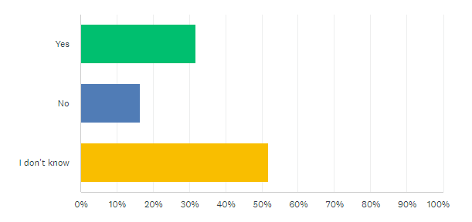 | Answer Choices Responses  Yes 31.81%  No 16.33%  Unsure 51.86%

Question 17: Are you aware of home energy grants available from the Sustainable Energy Authority of Ireland?
There are now more ways than ever to make homes warmer and more energy efficient. The Sustainable Energy Authority of Ireland provide home energy upgrade options as well as individual grants. More information can be found online at https://www.seai.ie/grants/home-energy-grants/

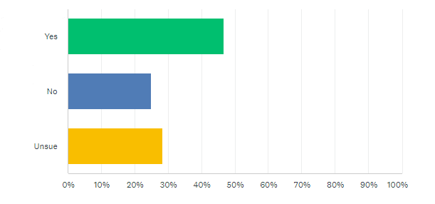 | Answer Choices Responses  Yes 46.70%  No 24.93%  Unsure 28.37%

Section 3: Climate Action

Question 18: What are your attitudes towards climate change?
Just over half of the respondents felt very strongly about working together as a community to slow down or stop climate change.
Answer Choices | Responses
I feel very strongly about working together as a community to slow down or stop climate change. | 55.68%
I do what I can for the environment, but I don't think there is much we can do. | 38.64%
I'm not really bothered by it. | 5.68%

Question 19: If any, what actions are you currently taking to reduce the impacts of climate change?
The most popular response from respondents was in relation to waste reduction and diverting waste from disposal by reusing, recycling and composting. This was followed by respondents reducing consumption of electricity, coal and gas, reducing heating use, reduced use of appliances and electrical devices etc.
Answer Choices | Responses
Reducing waste for example, reusing, recycling, and composting. | 76.70%
Reducing consumption of electricity, coal and gas, reducing heating use, reduced use of appliances and electrical devices etc | 56.53%
Buying local goods and products. Example: buying local produce, buying from local businesses. | 53.13%
Buying greener products, for example, products with less/no packaging. | 50.00%
Using energy-efficient products, reducing heat and air conditioning use, reduced use of appliances and electrical | 45.17%
Reducing water consumption. Example: reducing water usage, installing water saving devices. | 34.66%
Consciously buying less stuff or buying more pre-loved or second-hand items. | 34.38%
Using greener cleaning methods in the home. | 24.72%
Reducing fuel consumption, for example minimising travel by car and/or plane, drive energy/fuel efficient car, use public transportation, bike or walk. | 23.86%
Getting informed and involved. Example: joining an organization, attending a workshop, | 23.01%
Eating less meat. | 23.01%
Consciously holidaying local and cutting down on air miles. | 18.18%
Consciously having a smaller family. | 7.10%
None of the above. | 2.56%
Other (please specify) | 3.41%

Other answer choices included:
- Growing a vegetable garden and growing fresh vegetables and herbs
- Driving electric cars
- Reusing plastic bottles
- Having solar panels on your house

Question 20: What areas should climate action programmes target locally?
Respondents have suggested that the top three focus areas in relation to climate action in Letterkenny should be:
- Provision of more tree planting
- Work around renewable energy alternatives and energy efficiency upgrades in homes and businesses.
- Improved and enhanced bike and pedestrian facilities in the town.
Answer Choices | Responses
Grow more trees | 72.13%
Install solar panels on homes, businesses etc. | 64.66%
Enhanced bike and pedestrian facilities. | 55.46%
Renewable energy alternatives. | 54.60%
Energy efficiency upgrades for homes and businesses etc. | 53.45%
Improved land use in and around Letterkenny | 51.15%
Green building programme in Letterkenny. | 44.25%
Transition to electric vehicles and buses. | 43.39%
Water conservation. | 42.82%
Support for clean and greener travel and transportation | 41.38%
Improved air quality | 40.80%
Support for cleaner and greener power | 39.66%
Green skills training programmes | 31.90%
Improved community consultation and engagement | 29.89%
Consumption reduction | 27.30%
Carbon literacy awareness | 25.00%
Plant based diet and carbon footprint of food | 21.84%
Carbon literacy awareness | 25.00%
Other (please specify) | 4.31%

Other suggestions included:
- Making bus fares cheaper
- Increased education and awareness around biodiversity loss, especially in the younger generation
- Banning the use of herbicides and weedkillers such as ‘Roundup’

Question 21: Have you heard of the Sustainable Development Goals or Global Goals?
The Sustainable Development Goals (SDGs) or Global Goals are a collection of 17 interlinked global goals designed to be a ‘blueprint to achieve a better and more sustainable future for all’.
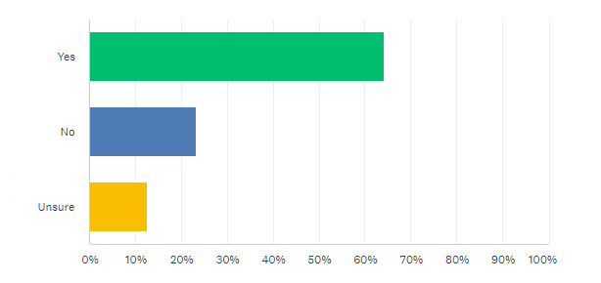 | Answer Choices Responses  Yes 64.08%  No 23.28%  Unsure 12.64%
The SDGs were set up in 2015 by the United Nations General Assembly and are intended to be achieved by 2030. The majority (64%) of respondents had heard of the SDGs but Letterkenny TidyTowns can still do more work to raise awareness of the goals by linking all our projects and actions to the goals.

Question 22: How prepared are you to take more personal action?
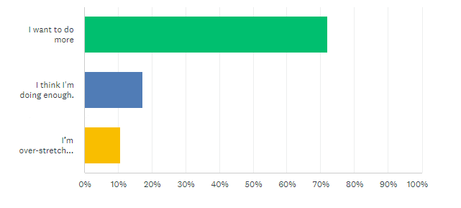
Answer Choices | Responses
I want to do more | 72.13%
I think I'm doing enough. | 17.24%
I’m over-stretched and need more information and help. | 10.63%

It is heartening that over 72% of respondents want to take more personal action to mitigate against environmental decline and climate change. Letterkenny TidyTowns will aim to be a conduit for this through out programme of projects, activities and events.
what would you like to see more of?

